**Assignment number: 10**

**Subject: COMPUTER GRAPHICS LAB**

Name: ***RIA MITTAL***

Class: ***SECOND YEAR ENGINEERING***

Division: ***B***

Roll no: ***222008***

Batch: ***B1***

**PROBLEM STATEMENT:**

Write a Java program to generate Hilbert curve using concept of fractals. AND Write a Java program to generate snowflake using concept of fractals.

Code:

package snowflake;

import java.awt.*;

import javax.swing.*;

public class Snowflake extends JApplet {

int level=0;

public void init()

{

String levelstr=JOptionPane.showInputDialog("enter the depth of recursion");

level=Integer.parseInt(levelstr);

}

public void paint(Graphics g)

{

drawSnow(g,level,400,400,600,400);

drawSnow(g,level,600,400,500,227);

drawSnow(g,level,500,227,400,400);

}

private void drawSnow(Graphics g,int lev,int x1,int y1,int x5,int y5)

{

int dx,dy,x2,y2,x3,y3,x4,y4;

if(lev==0)

{

g.drawLine(x1,y1,x5,y5);

}

else

{

dx=x5-x1;

dy=y5-y1;

x2=x1+dx/3;

y2=y1+dy/3;

x3=(int)(0.5*(x1+x5)+Math.sqrt(3)*(y1-y5)/6);

y3=(int)(0.5*(y1+y5)+Math.sqrt(3)*(x5-x1)/6);

x4=x1+2*dx/3;

y4=y1+2*dy/3;

drawSnow(g,lev-1,x1,y1,x2,y2);

drawSnow(g,lev-1,x2,y2,x3,y3);

drawSnow(g,lev-1,x3,y3,x4,y4);

drawSnow(g,lev-1,x4,y4,x5,y5);

}

}

}

Level 0:

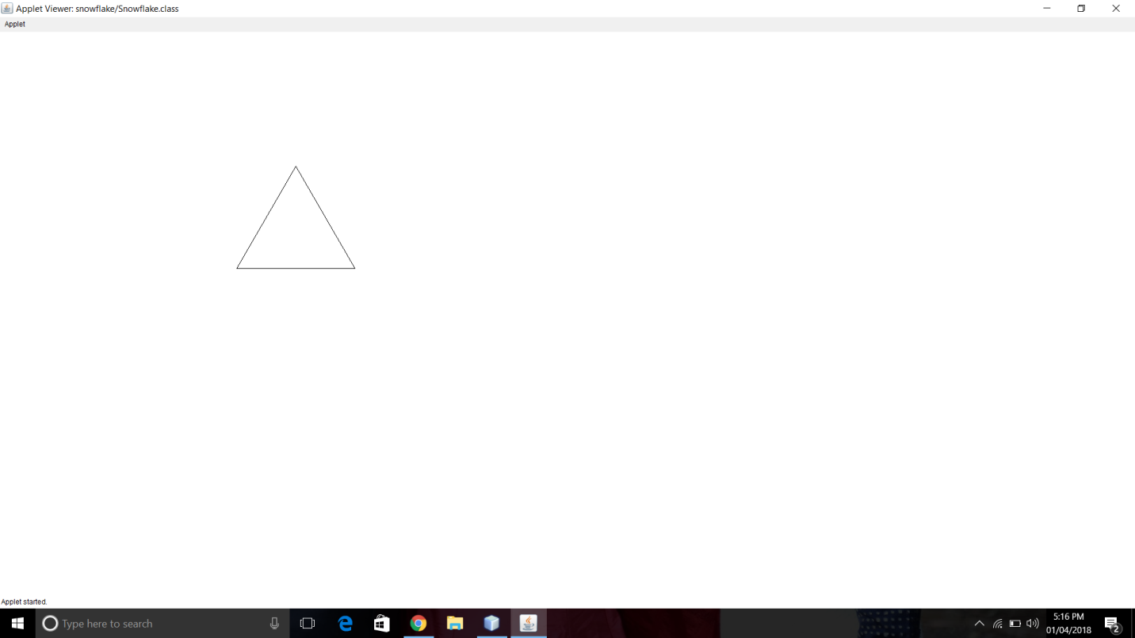

Level 2:

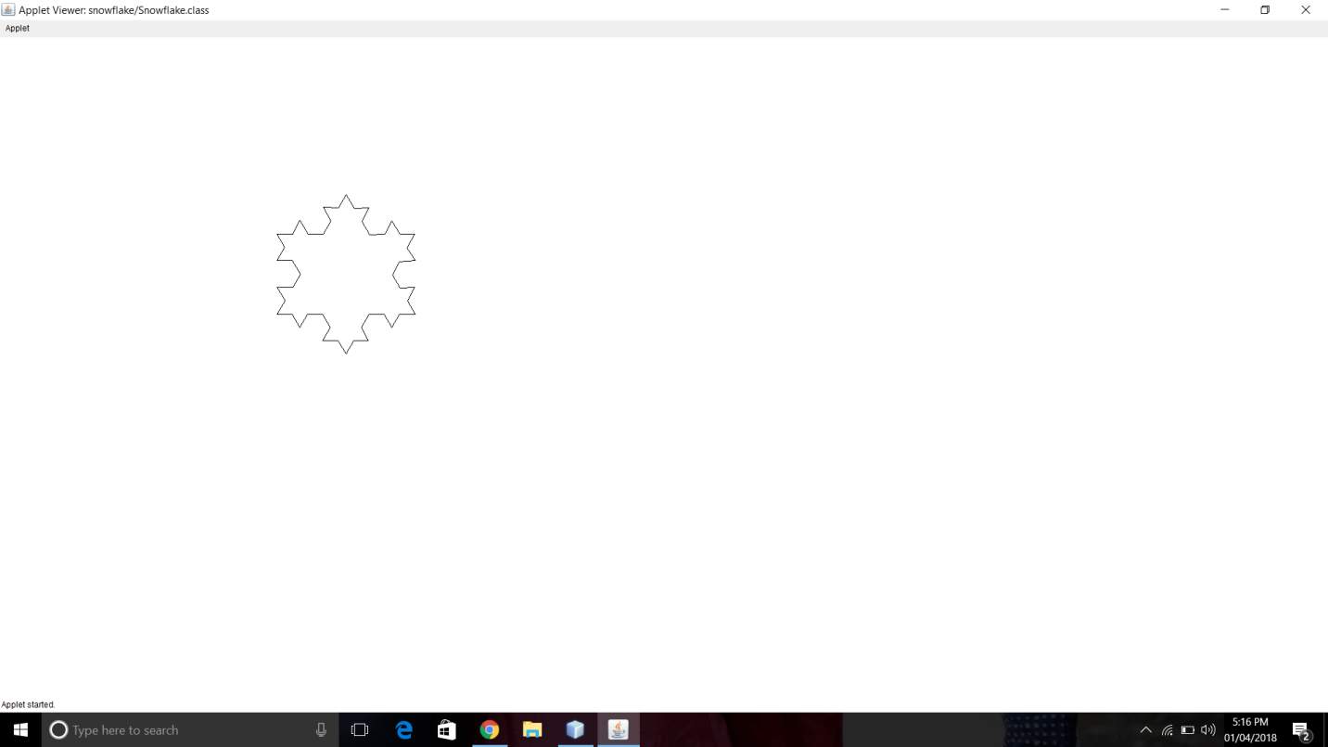

Level 5:

